Welcome to Your Recruit41 Interview!
We're excited to have you interview with us! To ensure a smooth and successful experience on the Recruit41 platform, please carefully review this guide.

Before Your Interview: Essential Setup Checklist

1. Use Google Chrome Browser (Required):
- Our platform exclusively supports the official Google Chrome browser.
- Unsupported Browsers: Please avoid using Chromium-based browsers (e.g., Brave, Arc), Safari, Microsoft Edge, or any mobile browsers.

2. Check your Camera and Microphone:
- Working Equipment: Ensure your camera and microphone are functioning correctly. Bluetooth headphones/earphones are recommended if available.
- Bluetooth Users: If using Bluetooth, set your devices as the default microphone and speaker in your operating system settings.
- Test Your Setup: Critically, test your camera and microphone at webcammictest.com well before your interview.

3. Prepare for Screen Sharing:
- During the interview, you might be asked to share your screen.
- Important: You must share your entire screen (not just a tab or window). This is crucial for us to evaluate any code you write. Without full screen sharing, we cannot grade your code.
4. Familiarize Yourself with Our Platform:
- Practice with a mock interview at https://demo.recruit41.com/. This will help you get comfortable with audio/video controls, screen sharing, and other platform features.

5. Create a Suitable Interview Environment:
- Quiet & Distraction-Free: Choose a location where you won't be interrupted.
- Good Lighting: Sit facing a light source so your face is clearly visible.
- Minimize Background Noise: Ensure a quiet setting for clear audio.

During Your Interview: Best Practices

1. Your Visibility & Positioning:
- Clear View: Your entire upper body (including face, arms, and hands) must be clearly visible to the interviewer throughout.
- Distance: This typically means sitting approximately 3 feet or more away from your computer screen.
- Pen & Paper: You may use pen and paper, but ensure your hands, pen, and paper remain visible.
- Exception for Coding: When asked to write code, you may move closer to the screen.
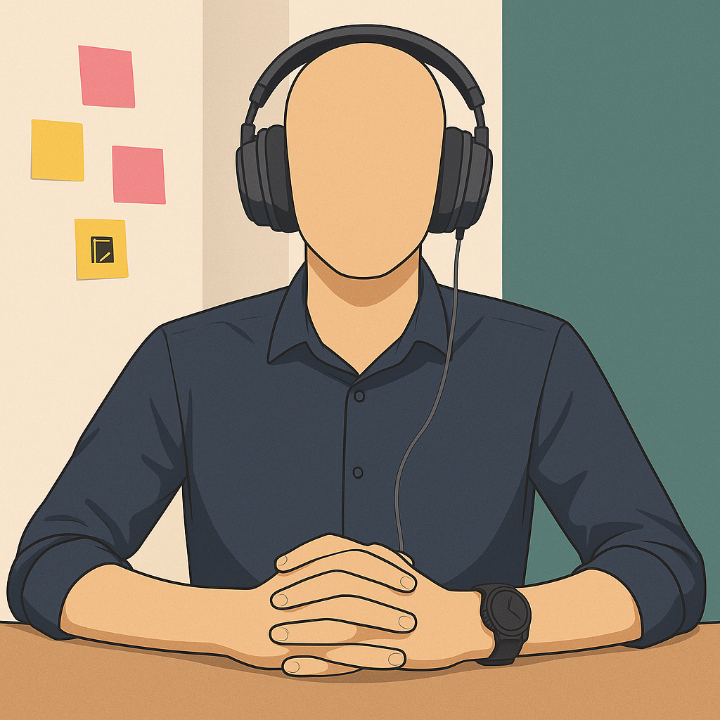 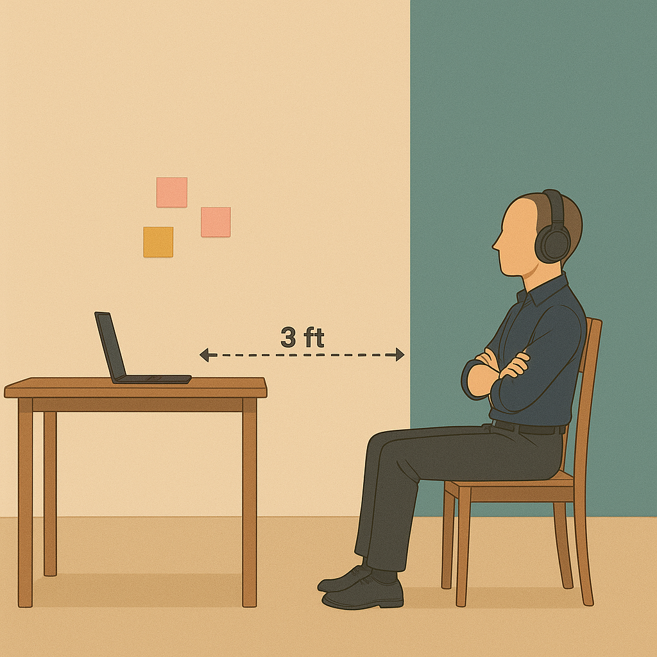
✅ Correct Position: Sitting at a proper distance, hands visible.
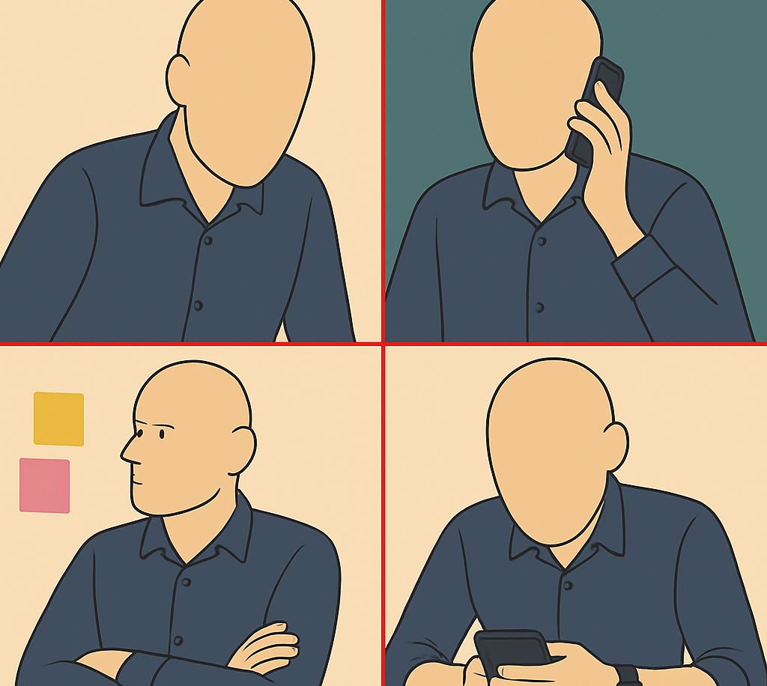
❌ Incorrect Position: Sitting too close, hands not visible,using your mobile phone, looking away during the interview and not wearing headphones.

2. Interacting with Kiran (Our AI Interviewer):
- If Kiran Seems Stuck: If Kiran appears unresponsive, prompt it by saying, "Hey Kiran, are you there?"
- Thoughtful Responses: Respond with a few complete sentences rather than 1-2 word answers. This helps Kiran (and any human reviewers) understand your thought process.
3. Communication Etiquette:
- Listen Actively: Allow the interviewer to finish speaking before you respond.
- Avoid Interruptions: Refrain from interrupting the interviewer during their question.
4. Technical Stability:
- Do Not Refresh or Close: Avoid closing the interview tab or hitting the refresh button.
- Pausing/Ending: If you need to stop or pause, use the "End Meeting" button located on the bottom control panel.
5. Getting Support:
- Live Chat (Recommended): Reach our live support team via the chat option available on the bottom control panel for the fastest response.
- Email: Alternatively, you can email us at support@recruit41.com.

Frequently Asked Questions (FAQs)
- The AI interviewer asks: “Are you there?” while I am answering the question. What should I do?
This usually means the AI cannot hear you. Please:

- Check if your audio is muted.
- Ensure you've granted microphone and camera permissions to the browser.
- Confirm the correct microphone is selected as default in your operating system.
- Test your setup at webcammictest.com
- What if the AI interviewer isn't responding?
First, try prompting it with "Hey Kiran, are you there?". If there's still no response, you can disconnect and rejoin the interview.
- I faced some platform-related issues during my interview. Will it affect my application?
No, any platform-related errors will not negatively impact your application.
- How can I reach out for help if I need it?
During the interview, use the live chat option on the bottom control panel. You can also email support@recruit41.com.
- What should I do if I get disconnected during the interview?
Don't worry! You can rejoin the same interview and continue from where you left off, provided it's within the stipulated time period.
- My camera isn’t being detected or is showing a blank screen. What should I do?
Ensure you select the correct camera source on the pre-meeting page before starting the interview.
- Is it necessary to keep my camera turned on throughout the interview?
Yes, to ensure a fair evaluation, your camera must remain switched on for the entire process.
- What if I lose my internet connection during the interview?
You can reconnect to the interview and resume from where you left off within the stipulated time limit.

